In case you have never played Angry Birds before here are the basics. The Pigs stole the eggs from the birds. The pigs are hiding behind different obstacles with the eggs. The birds are being launched at different parabolic arcs to try to get to the Pigs.
Directions: Let x be the Distance the Bird needs to travel and let y be the Height the bird travels at.
Step 1: Choose a map from the game via screen shot if you have the technology or design your own map. Draw the map and color it onto a poster board. Add the grid lines to the poster board / map. (Hint: make all grid lines the width of a yard stick apart. This makes everyone’s grid lines the same. It also makes it easy for you to add them neatly to the poster.)
Step 2: Find the following so that the bird will hit the target. Have the students take a picture of their poster board / map. Then upload it to Geogebra.org. Then have them follow the instruction in the video to construct the correct parabola that will make their bird hit the target.
1) The maximum height
2) The axis of symmetry
3) The distance traveled
Step 3: Write the quadratic equation for the parabola that will make the bird successfully hit the target.
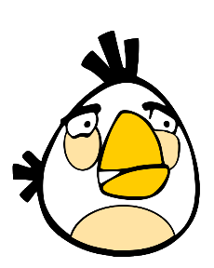
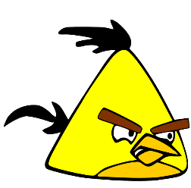
Step 4: Present your findings to the class.

Rubric: 100 Points Total
25 Points: Neatness and Accuracy of the Map
10 Points: Accuracy of Grid Lines on Poster Board
10 Points: Accuracy of Parabola on Geogebra.org
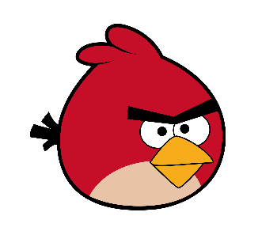
5 Points: Accuracy of Grid lines matching those on Geogebra.org
10 Points: Parabola tool on Geogebra.org works (verify with teacher)
10 Points: Finding Max Height
10 Points: Finding Axis of Symmetry
10 Points: Find the Distance Traveled
10 Points: Presentation to class

